**Questions**

Part 1 2

Part 2– 6

Part 3– 7

Part 4– 10

# Part 1

Frequency domain filters

Spatial domain filters

Convolution:

$$\left(x*y\right)\left(t\right)= \int_{k∈D}{x\left(k\right) ×y\left(t-k\right) dk}$$

$$\left(x*y\right)[n]= \sum_{k∈D}{x\left[k\right] ×y[n-k]}$$

$$g\left(x.y\right)= \sum_{s∈D_{1}}{\sum_{t∈D_{2}}{w\left(s.t\right)f\left(x-s.y-t\right) }}$$

The term kernel is used when you use convolutions to filter signals.

When the flipped window is completely inside the input signal, those results are called “valid” convolution.

*Kernels:*

**Sharpen kernel**

**Explain: In image processing, a kernel, convolution matrix, or mask is a small matrix. It is used for blurring, sharpening, embossing, edge detection, and more. This is accomplished by doing a convolution between a kernel and an image.**

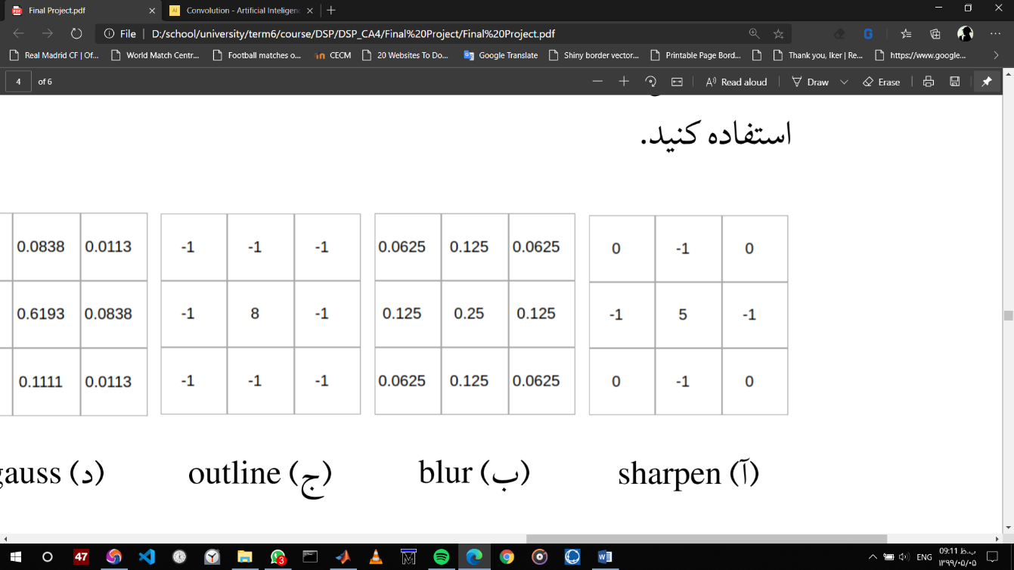

**Blur kernel**

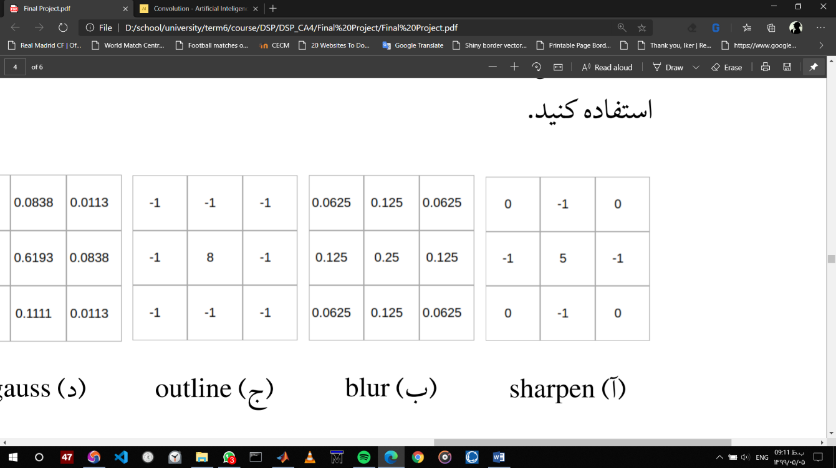 

**Outline kernel**

 

**Gauss kernel**

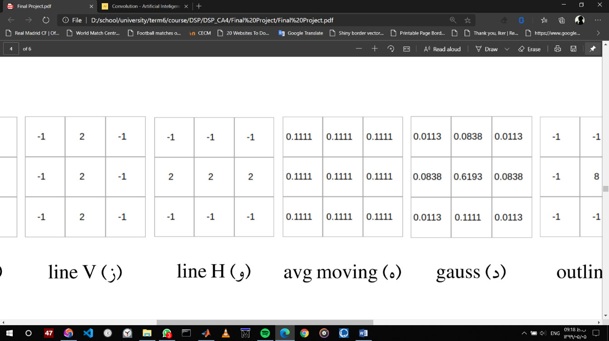 

**Avg moving kernel**

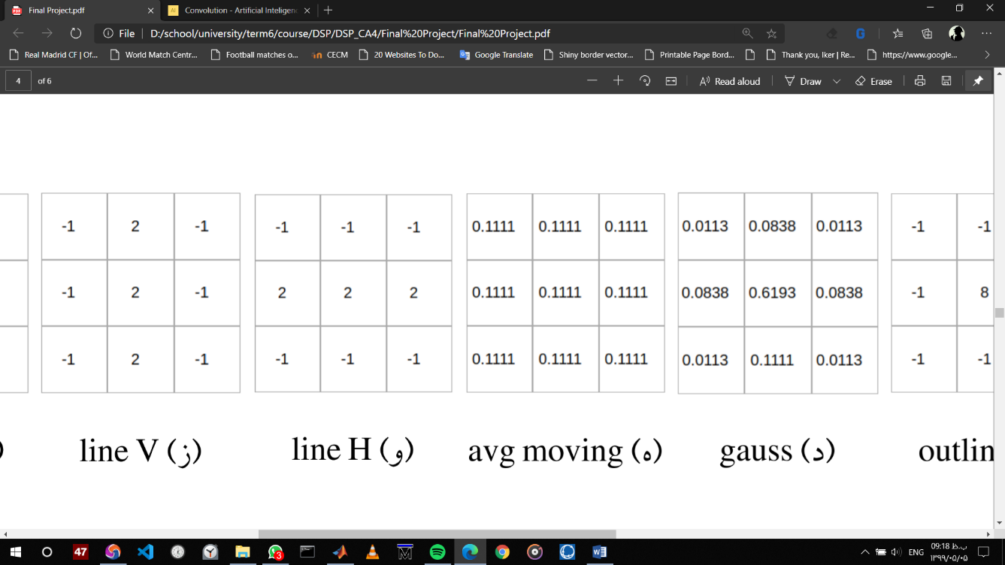 

**Line H kernel**

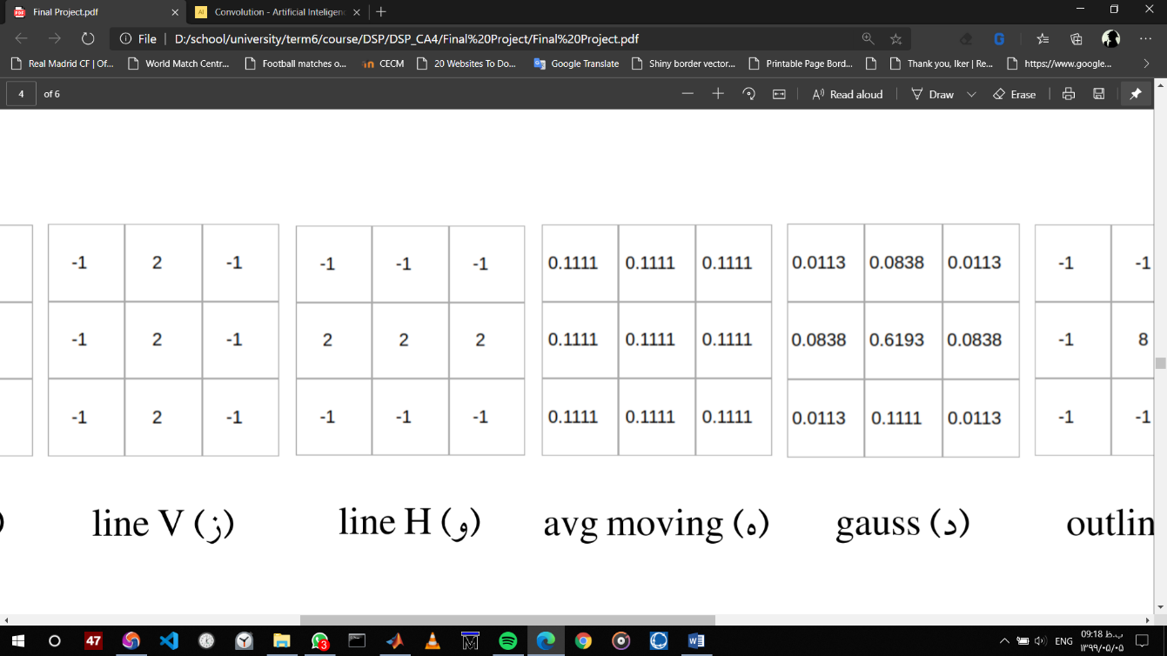 

**Line V kernel**

 

**Identity kernel**

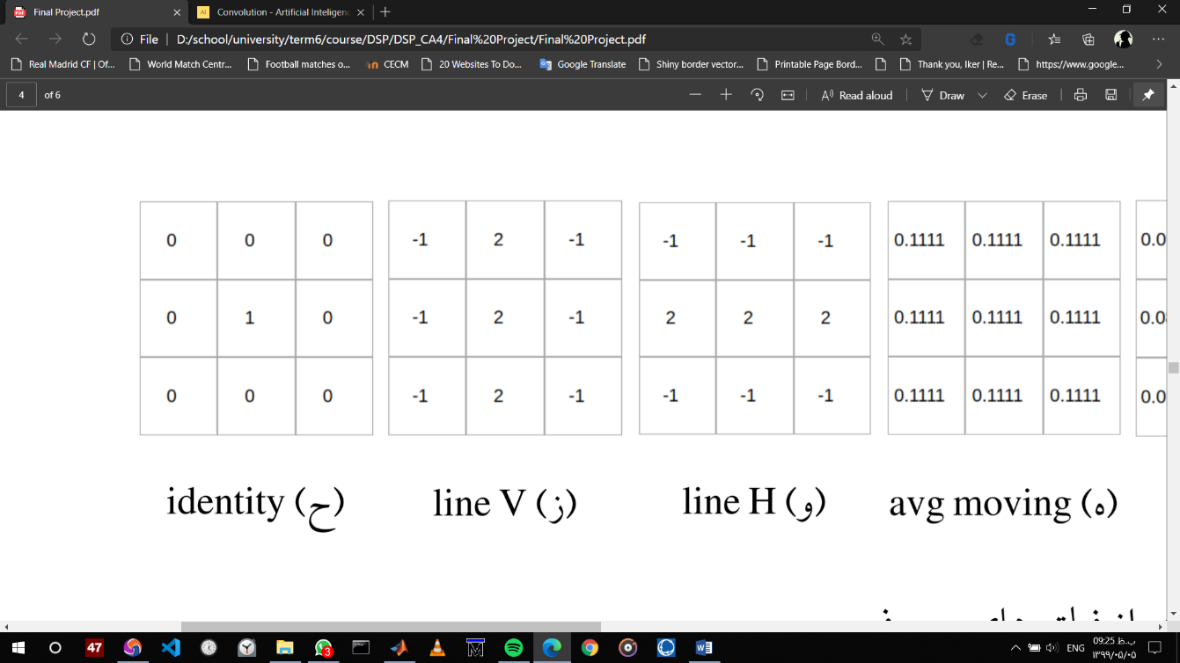 

# Part 2–

 

Scale 0.2



Scale 5

The differences of image quality is due to the loss of information when we use downsampling .



After filtering

after using gauss and avg filter

# Part 3–



H



V

As we can see lineH filter gives us length of our rectangule and lineV filter gives us width of the rectangular so the algorithm I used here to find the edges was based on this knowledge that higher values are mathced to the darker colors ( here black) so if we add up all numbers in each row and column as well we would find the indices of page edges .

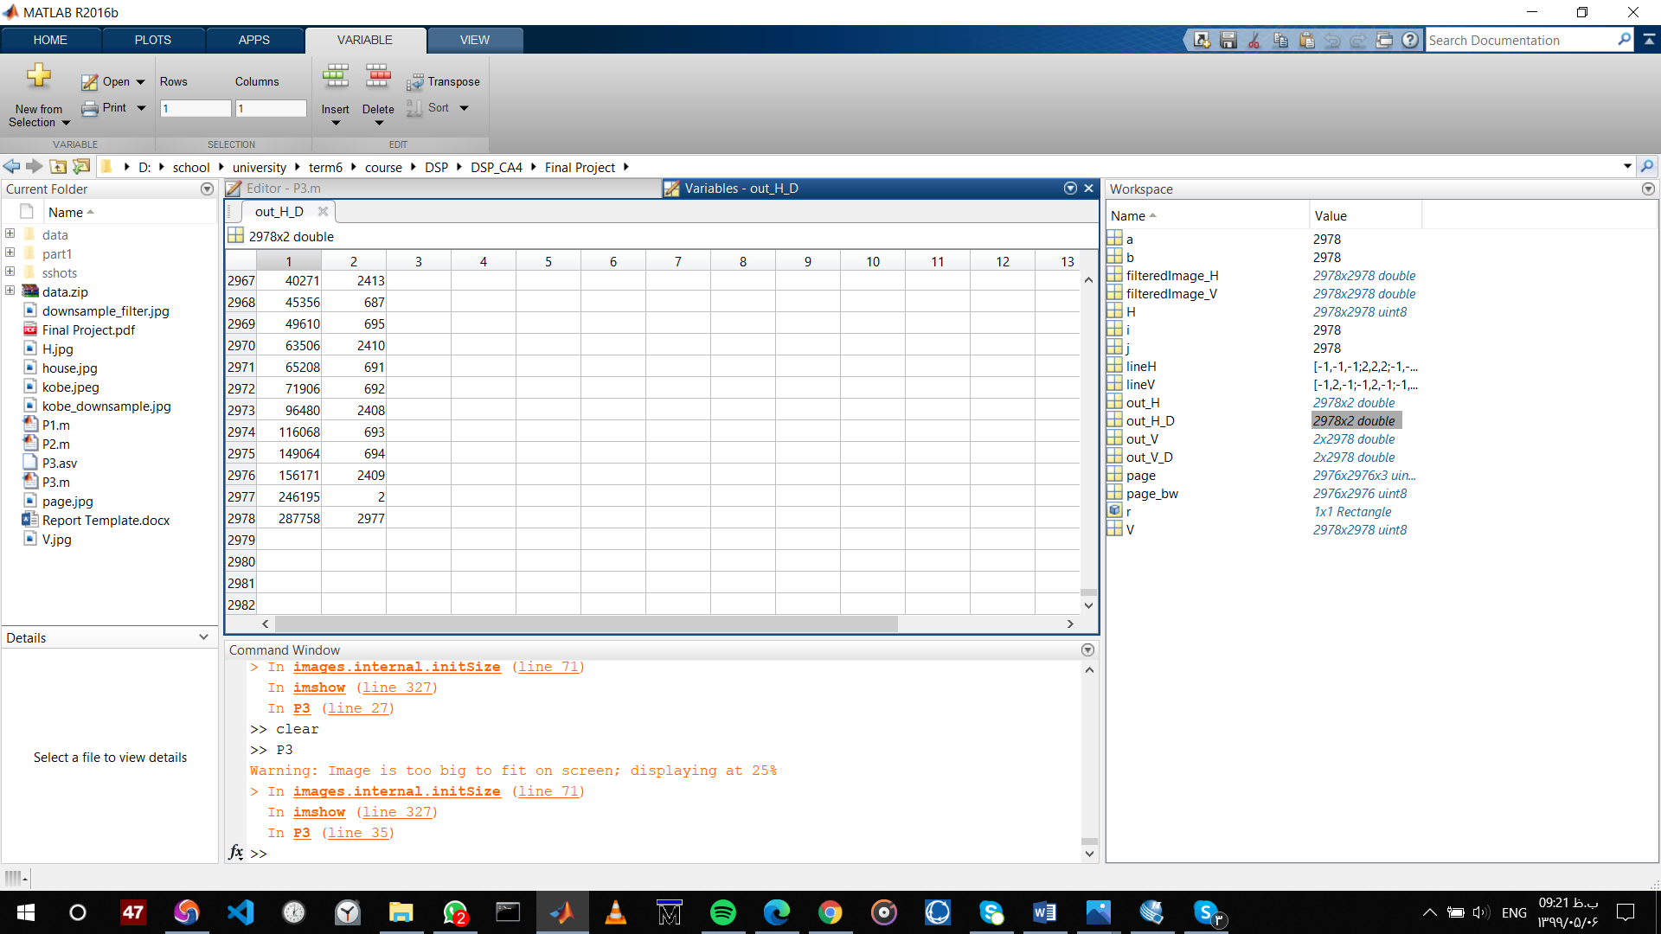

We can see that rows 690 & 2420 are definitely white.

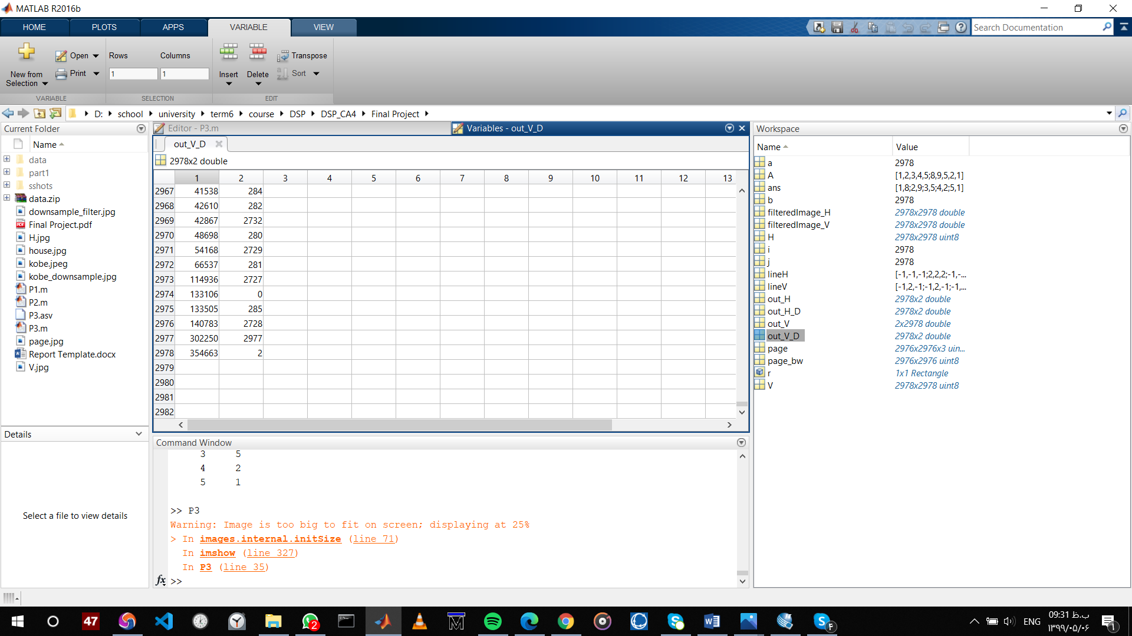

Columns are 275 & 2730

Pay attention that we have to give x,y,width,length of the trangle so we need the diffences of those two numbers .



# Part 4–

One ABS



One Fourier Transformed ABS



One ANGLE



One Fourier transformed ANGLE







1. Unchanged abs and noisy angle

SNR = 1 SNR = 0.5 SNR = 0.25



1. Unchanged angle and noisy abs

SNR = 1 SNR = 0.5 SNR = 0.25

  

As you can see the phase has much more impact on our image than magnitude.

Person A Person B

 

Person A



Person B



1.{A_abs & B_angle} 2.{B_abs & A_angle}

 

Image 1 is more like person B and image 2 is more like person A so here again because phase is more effective than magnitude.

.

.

.